P2P Local Mesh Communications Network for Developing Countries

Background

The Problem

There have been many text message based initiatives in developing countries over the last few years to achieve health, agriculture, education and economic development goals. Most initiatives use bulk text messaging to broadcast information such as crop reports and health advisories to the general population. In countries where the infrastructure is under developed this can be the most effective way of communicating. Often this is one way communications (broadcast) but where two way communications is provided the cost of the communications relative to local incomes is high and born by the individual and the cost and availability of staff to respond remain a challenge. More local support and a collaborative sharing of skills and resources locally is a more viable solution but the cost of using the existing telecommunication infrastructure remains an issue. Creating a local mesh network for peer to peer communications between individuals in small communities is a way of facilitating that communications while reducing the recurring costs. This infrastructure would also supplement the existing and more expensive cost of the existing telecommunications infrastructure which has a recurring cost of each message sent.

Special Considerations

Penetration Rates of Smartphone

The solution requires that users have access to smartphones, phone that would allow third party applications to be loaded on the device. Feature phones that do not allow third party applications to be loaded have in the past been more common but the migration to smartphone in developing countries is occurring. An excerpt from a 2015 article predicted that :

“Only 27% of cellphones sold in Africa and the Middle East in 2019 will be feature phones. The vast majority will be smartphones, according to new research from International Data Corp (IDC).

Regional smartphone shipments will total 155m units in 2015 after increasing by 66% year on year during the first quarter, according to the technology research and consulting firm’s Q1 2015 Mobile Phone Tracker report. During the quarter, 47% of cellphones sold during the first quarter in Africa were smartphones. Feature-phone sales on the continent slumped by 20% year on year, according to IDC.”

The inflection point where smartphone sales would match or exceed feature phone sales was predicted to be in 2014. As shown below sales flattened and just as the inflection point was being reached in 2014.

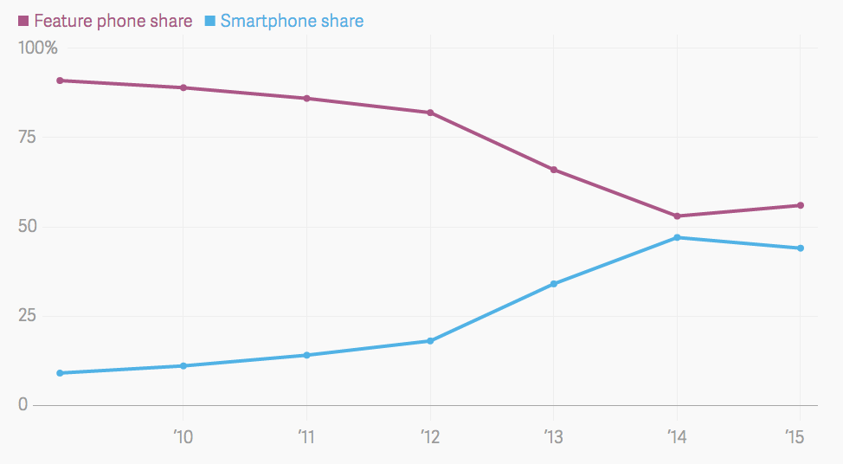

Graph of percentage of feature phone sales versus smartphone sales in Africa by year

A more recent article suggests that the predictions were wrong and that smartphone sales have recently declined primarily due to a slow down in the regional economies. There are similar trends in other parts of the world in countries such as a in Myanmar.

The slow down is predicted to be temporary though as:

“The global smartphone market is shifting. Over the next few years, the vast majority of growth is expected to come from developing countries as the average selling price of devices continues to fall.”

Smartphone ownership in developing countries continues to rise. In 2015 54 % reported using the internet at least occasionally or owning a smartphone.

“But smartphone ownership rates in emerging and developing nations are rising at an extraordinary rate, climbing from a median of 21% in 2013 to 37% in 2015”

Lack of Sense of Ownership in Developing Countries

The lack of local ownership of community based project is a documented issue for projects in developing countries. There are cultural differences (especially in traditionally nomadic cultures) about the ownership of infrastructure and resources that is hard to overcome as resources are considered transitory in nature and as a result the commitment to maintain the infrastructure is lacking. As a result any infrastructure needs to be self sustaining, be easily to deploy and require little to no maintenance to keep running.

Not Only A Developing World Problem

Though the previous discussion has been about developing countries, underserved communities surprisingly also exist in first world countries. The downtown Vancouver East Side for example is Canada’s poorest neighbourhood and home to many people on social assistance and many have drug addiction issues. The Vancouver Community Network,, a non-profit that provides free access to the internet for disadvantage community members, recently launched the Street Messaging System.

“The Steet Messaging System recognizes that locally more than 63% of street-involved youth and 30% of marginalized individuals over the age of 30 have a cellphone - this online tool was developed to freely send alerts about Shelter, Food, Health, Jobs/training and for emergencies. The SMS also enables organizationally-controlled group messaging functions which makes it possible to send the alerts and updates to an organization's current client lists, program participants, staff and professional networks.”

The Technology Solution

Introduction

There are unique cultural and economic issues that exist in developing countries and there is often a tendency to use first world solutions to address issues in developing countries that are not based in the reality of that actual exist locally in these countries. Rather that trying to solve national information infrastructure issues that require the investment of significant capital, this system tries to solve the need to communicate locally using a more modest investment in infrastructure. It use well established communication protocols and lower cost, proven, off the shelf integrated micro-controller boards with WiFi and Bluetooth build in.

Local Mesh Network Connectivity

The objective is to create a localized mesh of micro nodes that will create a Bluetooth enabled communications infrastructure in rural areas.T he micro nodes in turn will be connected to each other through WiFI (30 metre range) and augmented by long range WiFi systems with directional antennae that can have a range of several kilometres when necessary. The bandwidth of the system is designed to support chat and messaging functions. It is not intended to provide access to the internet and the broader range of content their such as video and pictures. The system will allow locals to stay connected locally and will allow civic and other governmental service to push information to end users and where appropriate individuals can have two way conversations and exchange of information. WiFi and Bluetooth have the added advantage of not requiring specialized licenses as the systems operate in the consumer band in most countries.

Fault Tolerance of the Wireless System

Self Sustaining Power

The nodes in the mesh network are designed to be powered from solar cells and therefore be self sustaining. Power draw of a Raspberry PI with HDMI off, LEDs off, onboard WiFi active is 250 mA.

Solar cell will be used to power the system when the sun is out. Excess power will be stored in super capacitors.

“Super capacitors store electrons in a capacitive field with very high efficiency, high rate charge and discharge cycles (interchangeably called an ultracapacitor or an EDLC – electrochemical double layer capacitor). Electrons are stored in a capacitance field and discharged on demand, making for a fast, rechargeable device that can store and deliver peak power pulses with very high cycle life (millions of cycles).”

“This hybrid cell stores energy in both Faradaic and capacitive modes, making for a higher energy density closer to lead acid battery energy densities, with very fast recharge, like a capacitor. It is much safer than a lithium battery. “

“ Super Capacitors are a lead battery replacement – 3X to 5X longer cycle life, 30% greater energy density and higher efficiency in energy storage cycling (95% compared to 65%)”

Peer to Peer Messaging Application

Peer to Peer Message between individuals and local civic leaders can be facilitated by existing peer to peer messaging applications such a Firechat.

“FireChat creates a mesh network using Bluetooth and peer-to-peer WiFi. FireChat transmits messages and pictures offline between devices that are located within 200 feet of one another.

Thanks to FireChat’s innovative multi-hop and store-and-forward capabilities, FireChat users form a network that increases in size with the number of devices. It allows messages to hop from one device to the next in order to reach the recipient(s). This is why the more people use FireChat, the better and the larger the network becomes (unlike with cellular networks).

On the mesh network, messages are transmitted seamlessly from one device to the next in order to reach the recipient(s). When an Internet connection or cellular network is available, FireChat uses them to reach remote recipients.

Public messages are visible by anyone. Private messages are encrypted and can only be seen and read by the sender and the recipient.”

Centeralized Server for Community Annoucements

National and wider regional community messages can still be sent through broadcast text messaging. Costs can be reduced to sending the public announcement message to a one of the nodes in the network which also is equipped with a SIM code.
That node can then forward the messages to each of the individual users through the regional mesh network. Though broadcast text message can be cheap on a relative basis there is still a per message charge. Incremental cost saving can be passed on to send more frequent but still relevant community messages.

Warren A Kaplan. “Can the ubiquitous power of mobile phones be used to improve health outcomes in developing countries?”. 23 May 2006. https://globalizationandhealth.biomedcentral.com/articles/10.1186/1744-8603-2-9
Carole Déglise;L. Suzanne Suggs3; Peter Odermatt. “Short Message Service (SMS) Applications for Disease Prevention in Developing Countries”. J Med Internet Res 2012;14(1):e3 . http://www.jmir.org/2012/1/e3/
Carole Déglise; , L Suzanne Suggs; Peter Odermatt. “SMS for disease control in developing countries: a systematic review of mobile health applications”. Published July 23, 2012. http://journals.sagepub.com/doi/abs/10.1258/jtt.2012.110810
If Your Business Is Betting On Smartphones Overtaking Feature Phones In Africa, You Might Want To Look At This 13 Apr 2017 by Sloane Hunter in Mobile, Tech/Sci, Vibe . http://www.2oceansvibe.com/2017/04/13/if-your-business-is-betting-on-smartphones-overtaking-feature-phones-in-africa-you-might-want-to-look-at-this/#ixzz4eaSlRaPU
If Your Business Is Betting On Smartphones Overtaking Feature Phones In Africa, You Might Want To Look At This 13 Apr 2017 by Sloane Hunter in Mobile, Tech/Sci, Vibe . http://www.2oceansvibe.com/2017/04/13/if-your-business-is-betting-on-smartphones-overtaking-feature-phones-in-africa-you-might-want-to-look-at-this/#ixzz4eaSlRaPU
If Your Business Is Betting On Smartphones Overtaking Feature Phones In Africa, You Might Want To Look At This 13 Apr 2017 by Sloane Hunter in Mobile, Tech/Sci, Vibe . http://www.2oceansvibe.com/2017/04/13/if-your-business-is-betting-on-smartphones-overtaking-feature-phones-in-africa-you-might-want-to-look-at-this/#ixzz4eaSlRaPU
Myanmar Smartphone Shipments Up to 26% YoY, According to IDC . 21 Dec 2016. https://www.idc.com/getdoc.jsp?containerId=prAP42197616
THE SMARTPHONE MARKET, BY COUNTRY: Adoption, platform, and vendor trends in the US, China, and India. Will McKitterick. Apr. 1, 2016, 12:16 PM. http://www.businessinsider.com/the-smartphone-market-by-country-adoption-platform-and-vendor-trends-in-the-us-china-and-india-2016-4
Jacob Poushter. “Smartphone Ownership and Internet Usage Continues to Climb in Emerging Economies”. Pew Research Center. February 22, 2016. http://www.pewglobal.org/2016/02/22/smartphone-ownership-and-internet-usage-continues-to-climb-in-emerging-economies/
Jacob Poushter. “Smartphone Ownership and Internet Usage Continues to Climb in Emerging Economies”. Pew Research Center. February 22, 2016. http://www.pewglobal.org/2016/02/22/smartphone-ownership-and-internet-usage-continues-to-climb-in-emerging-economies/
Peter Gutwa Oino; Geofrey Towett; K. K. Kirui; Cyrillah Luvega. “THE DILEMMA IN SUSTAINABILITY OF COMMUNITY-BASED PROJECTS IN KENYA” http://gjar.org/publishpaper/vol2issue4/d177r18.pdf
Hopper, Tristan. “Vancouver’s ‘gulag’: Canada’s poorest neighbourhood refuses to get better despite $1M a day in social spending” . November 14 2014. http://news.nationalpost.com/news/vancouvers-gulag-canadas-poorest-neighbourhood-refuses-to-get-better-despite-1m-a-day-in-social-spending
https://www.streetmessagingsystem.ca/
https://www.streetmessagingsystem.ca/about
Lakshminarayan Subramanian; Sonesh Surana, Rabin Patra, Sergiu Nedevschi, Melissa Ho, Eric Brewer; Anmol Sheth. “Rethinking Wireless for the Developing World”. https://www.ab9il.net/wlan-projects/large_wild.pdf
http://www.pidramble.com/wiki/benchmarks/power-consumption
http://www.paperbatteryco.com/technology/energy-storage/
https://play.google.com/store/apps/details?id=com.opengarden.firechat&hl=en

